Algorithm for file updates in Python

Project description
In this scenario, there is content that is restricted to an allowed list of IP addresses. These IP addresses are stored in a file called “allow_list.txt”. There is a separate remove list that contains IP addresses that should not be allowed to access the content. I used a Python algorithm to update the “allow_list.txt” file and remove the IP address that should no longer have access.

Open the file that contains the allow list
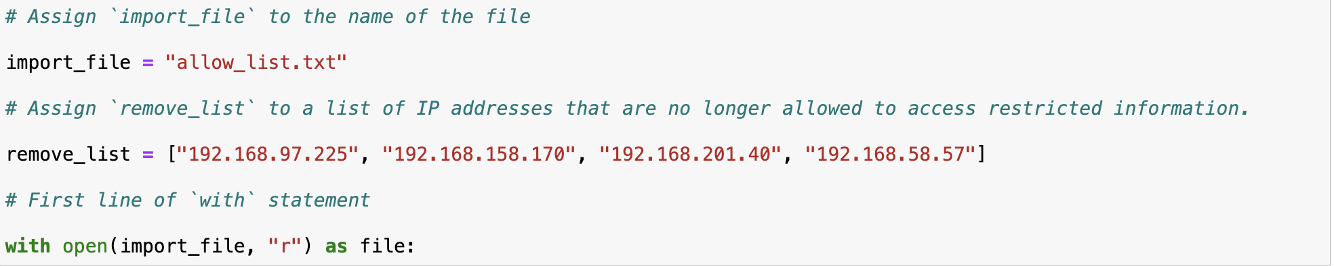
To open a file using Python, I used the following code. With allows me to open the file and close it after use, which is best Python practice. Open indicated that I am opening the file. The following parameter, import_file, is the file that I want to open. “R” shows that I am reading the file. And lastly, as file: is to open the file.

Read the file contents
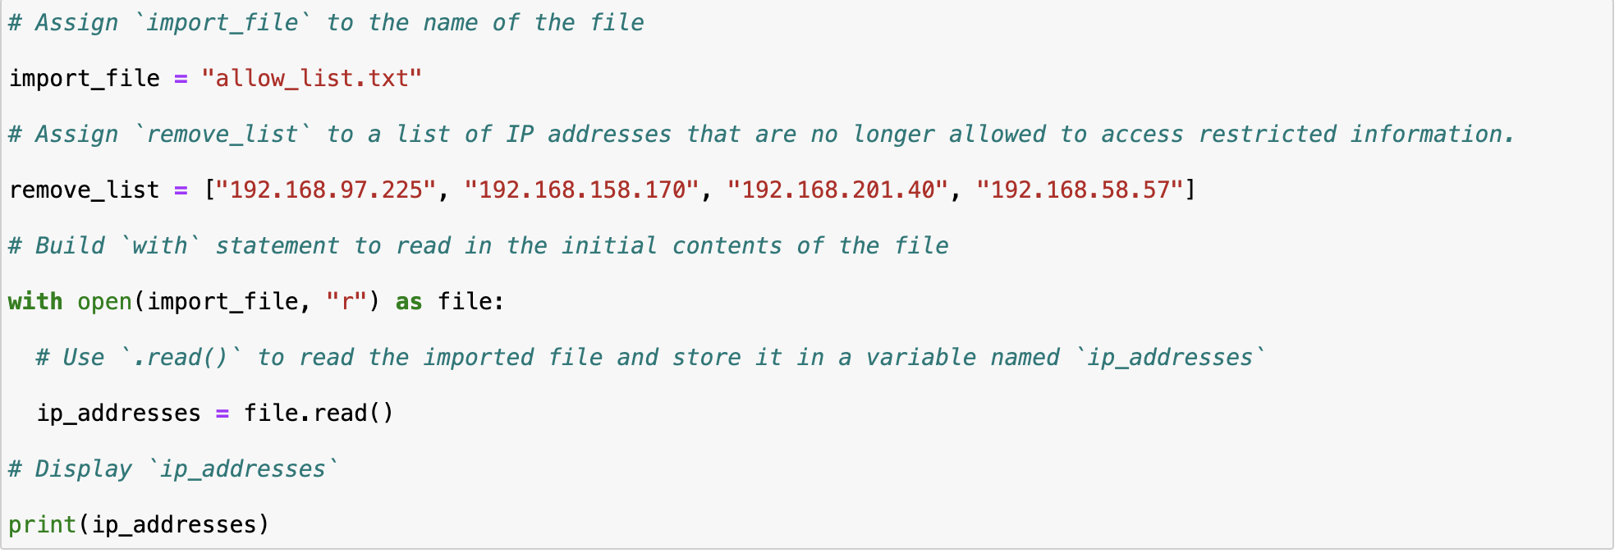
The next step is to read the contents of the file. To do this, I assign ip_addresses = file.read to show that the imported file will be stored in a variable called ip_addresses. Then, I print(ip_addresses) to read the contents of the file.

Convert the string into a list
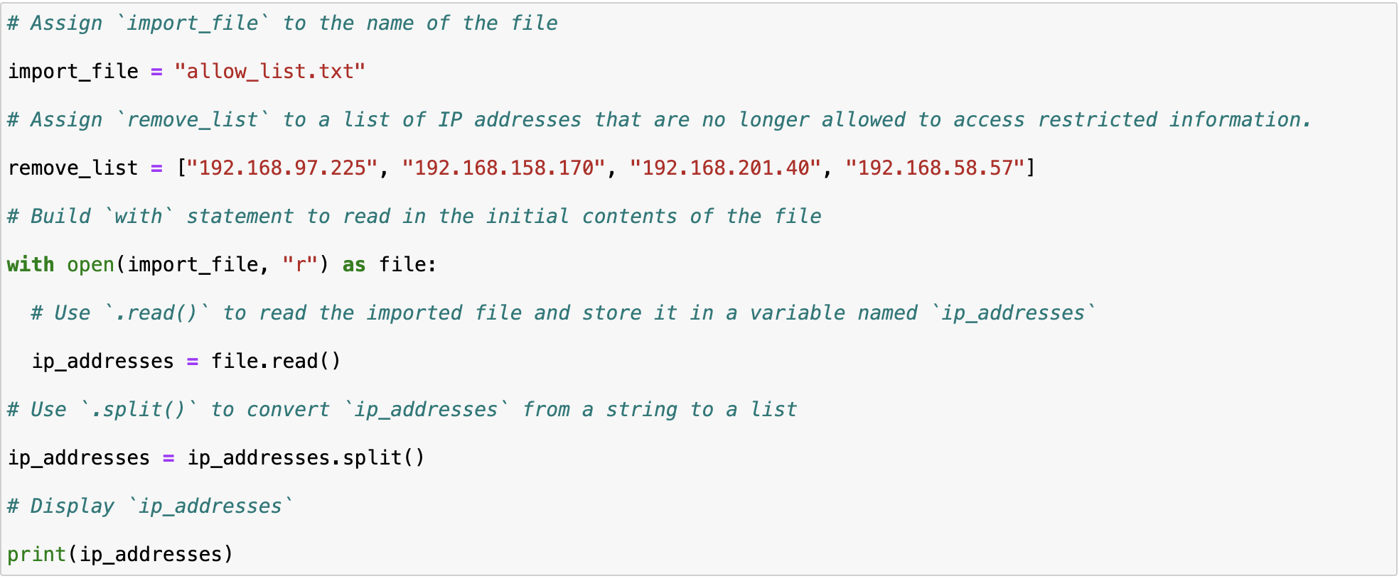
To convert the ip_addresses to a more readable format, i used the ip_addresses = ip_addresses.split(). The split() function allows me to convert data from a string to a list.

Iterate through the remove list
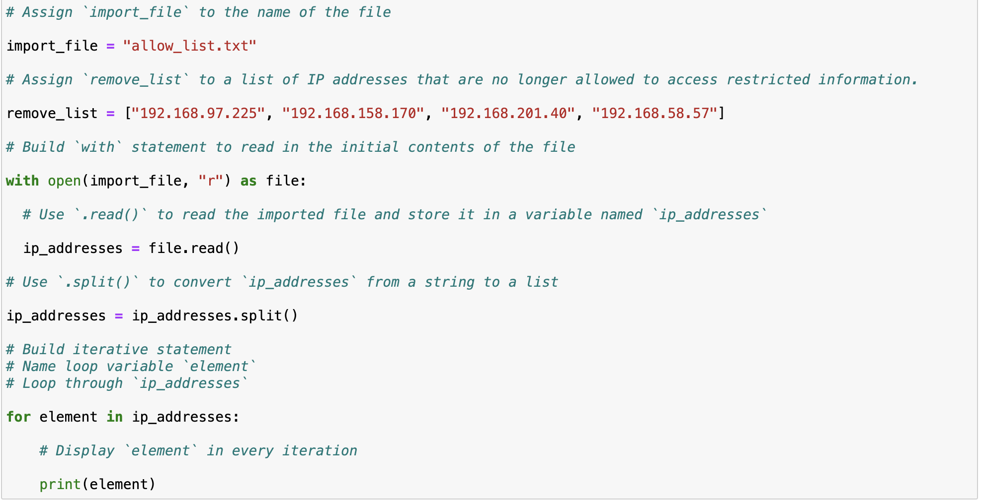
To check each element in the list, I use the iterative statement for element in ip_addresses. This creates a loop variable named ‘element’ and will loop through every item in ip_addresses.

Remove IP addresses that are on the remove list
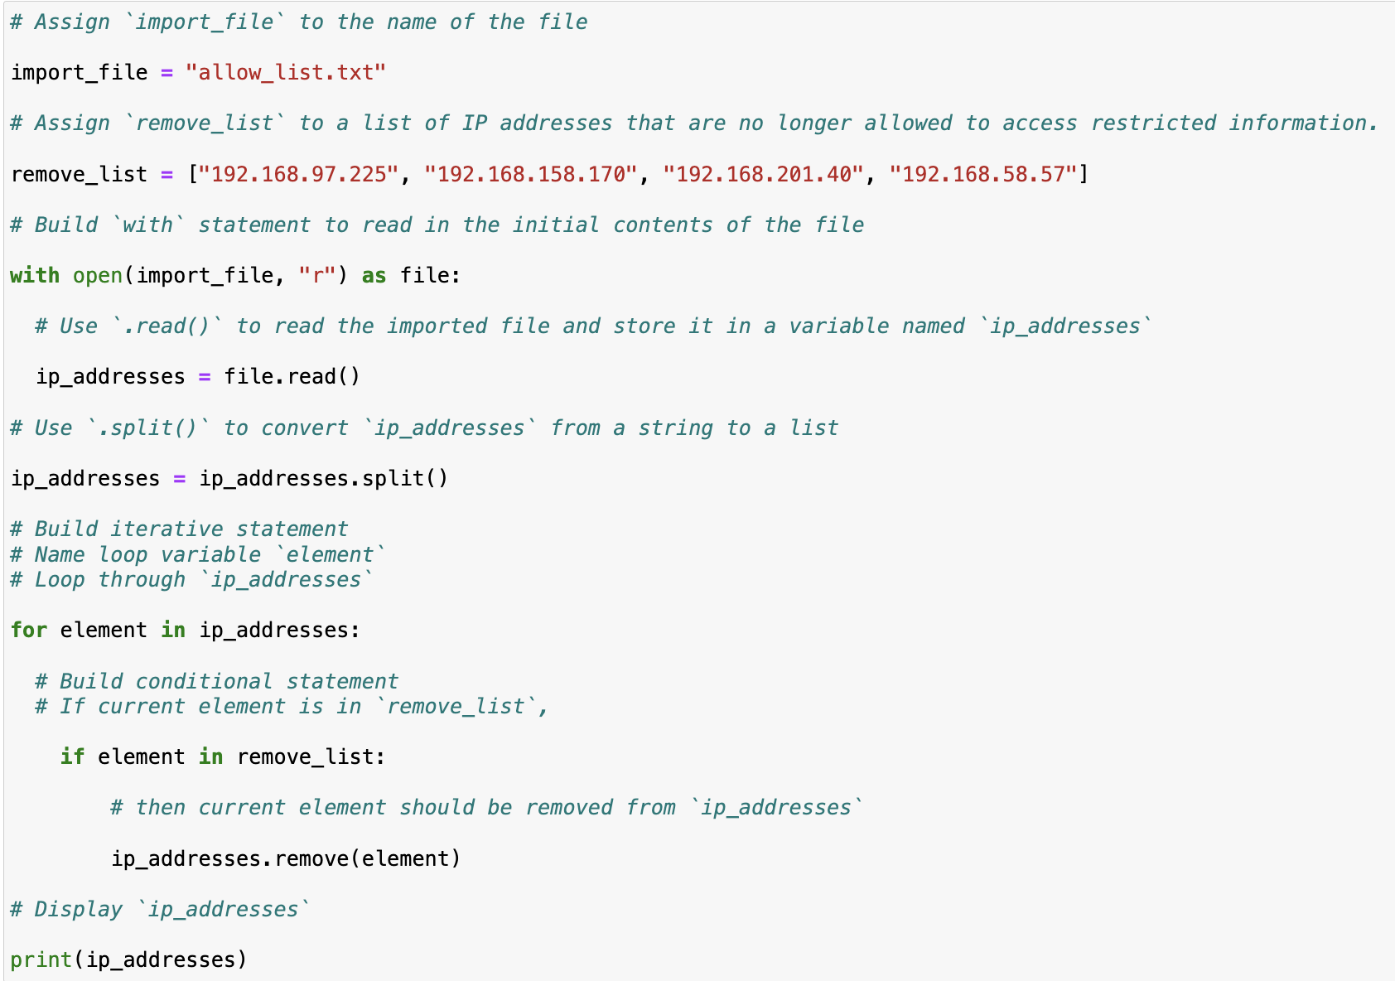
Next, I wrote a conditional statement, if element in remove_list to check if the element needs to be removed. ip_addresses.remove(element) indicates that from the ip_address list, the element needs to be removed if it is also in the remove_list. The remove() method is possible to use because there are no duplicates in the ip_addresses list.

Update the file with the revised list of IP addresses
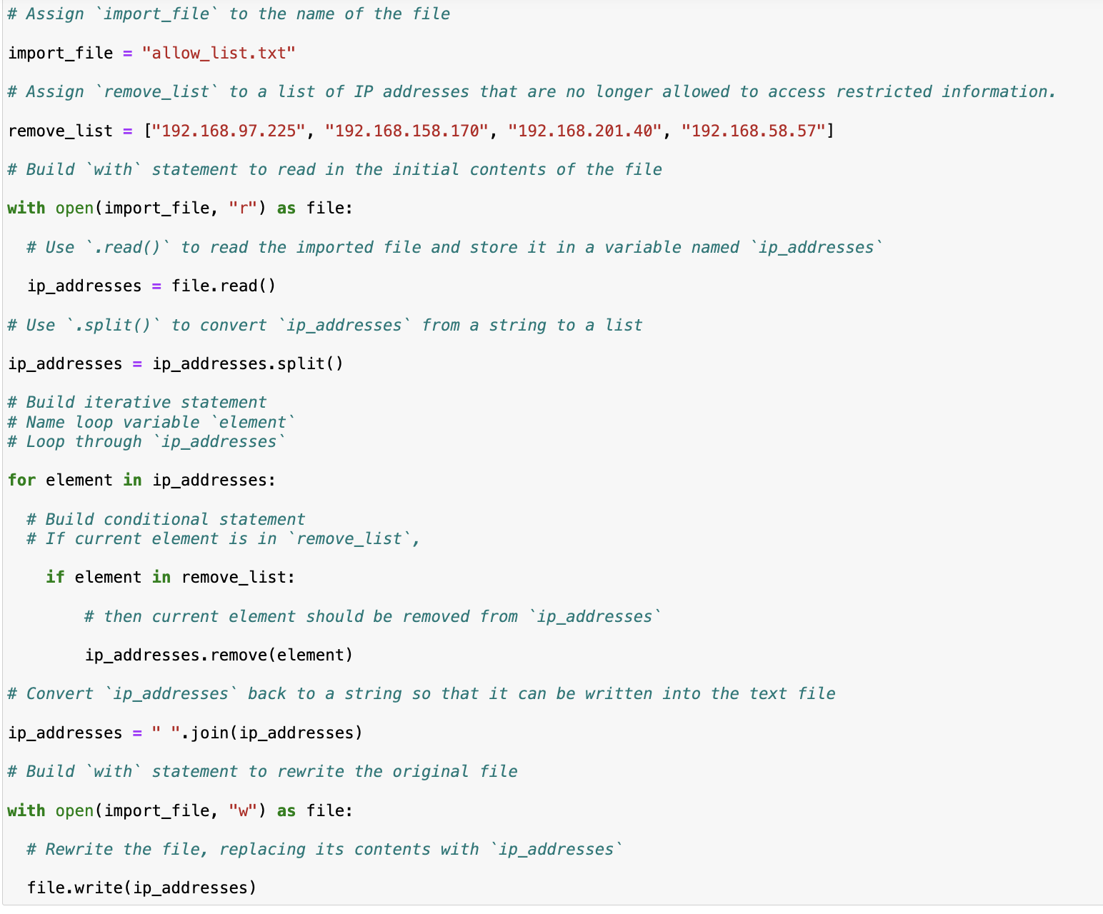
Next, I use the .join() to convert the list back to a string: ip_addresses = “ “. join(ip_addresses). To rewrite the original file, I use the same syntax as before : with open(import_file, “w”) as file. In this instance, “w” indicates that the file will be rewritten.

Summary

I created an algorithm to remove IP address that were in the remove_list from the “allow_list.txt” file of allowed IP addresses. To do this, I opened a file, converted it to a string to be read, and converted the string to a list, which was stored in the variable ip_addresses. Then I iterated through each IP address in remove_list. During the iteration, I checked if the element was a part of the ip_address list. If it was, I used the .remove() method to remove the element from ‘ip_addresses’. After, I used the ‘.join()’ method to convert ‘ip_addresses’ back into a string so I could write the contents of ‘allowed_list.txt’ file with the new list of IP addresses.

